* Components Used

1. NodeMCU V3

2. DHT11 Sensor Module

3. MQ-135 Gas Sensor Module

4. Breadboard

5. Connecting Wires

6. AC-DC Adapters

7. LEDs

8. Resistors

* CIRCUIT DIAGRAM:

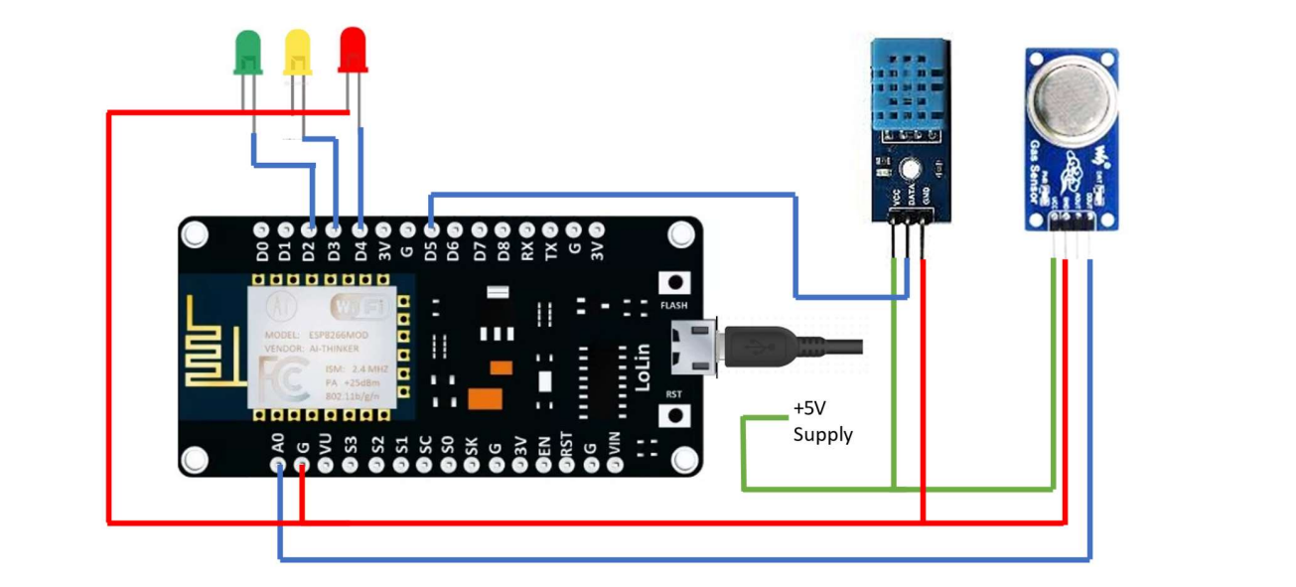

* PROGRAM:

#include <ESP8266WiFi.h>

#include <DHT.h>

#include <ThingSpeak.h>

DHT dht(D5, DHT11);

#define LED_GREEN D2

#define LED_YELLOW D3

#define LED_RED D4

#define MQ_135 A0

int ppm=0;

int gas_sensor;

float m = -0.3376; //Slope

float b = 0.7165; //Y-Intercept

float R0 = 3.12; //Sensor Resistance in fresh air from previous code

WiFiClient client;

long myChannelNumber = 123456; // Channel id

const char myWriteAPIKey[] = "API_Key";

void setup() {

// put your setup code here, to run once:

Serial.begin(9600);

pinMode(LED_GREEN,OUTPUT);

pinMode(LED_YELLOW,OUTPUT);

pinMode(LED_RED,OUTPUT);

pinMode(MQ_135, INPUT);

WiFi.begin("WiFi_Name", "WiFi_Password");

while(WiFi.status() != WL_CONNECTED)

{

delay(200);

Serial.print(".");

}

Serial.println();

Serial.println("NodeMCU is connected!");

Serial.println(WiFi.localIP());

dht.begin();

ThingSpeak.begin(client);

}

void loop() {

float sensor_volt; //Define variable for sensor voltage

float RS_gas; //Define variable for sensor resistance

float ratio; //Define variable for ratio

int sensorValue;//Variable to store the analog values from MQ-135

float h;

float t;

float ppm_log; //Get ppm value in linear scale according to the the ratio value

float ppm; //Convert ppm value to log scale

h = dht.readHumidity();

delay(4000);

t = dht.readTemperature();

delay(4000);

sensorValue = analogRead(gas_sensor); //Read analog values of sensor

sensor_volt = sensorValue*(5.0/1023.0); //Convert analog values to voltage

RS_gas = ((5.0*1.0)/sensor_volt)-1.0; //Get value of RS in a gas

ratio = RS_gas/R0; // Get ratio RS_gas/RS_air

ppm_log = (log10(ratio)-b)/m; //Get ppm value in linear scale according to the ratio value

ppm = pow(10, ppm_log); //Convert ppm value to log scale

Serial.println("Temperature: " + (String) t);

Serial.println("Humidity: " + (String) h);

Serial.println("Our desired PPM = "+ (String) ppm);

ThingSpeak.writeField(myChannelNumber, 1, t, myWriteAPIKey);

delay(20000);

ThingSpeak.writeField(myChannelNumber, 2, h, myWriteAPIKey);

delay(20000);

ThingSpeak.writeField(myChannelNumber, 3, ppm, myWriteAPIKey);

delay(20000);

if(ppm<=100)

{

digitalWrite(LED_GREEN,HIGH);

digitalWrite(LED_YELLOW,LOW);

digitalWrite(LED_RED,LOW);

}

else if(ppm<=200)

{

digitalWrite(LED_GREEN,LOW);

digitalWrite(LED_YELLOW,HIGH);

digitalWrite(LED_RED,LOW);

}

else

{

digitalWrite(LED_GREEN,LOW);

digitalWrite(LED_YELLOW,LOW);

digitalWrite(LED_RED,HIGH);

}

delay(2000);

}

* OUTPUT:

